**What is a Hazard?**

A hazard is something that can cause harm, e.g. electricity, items on the floor, noise, fire etc.

**What is a Risk?**

A risk is how severe the hazard is x the likelihood that it will happen.

When looking at how you can reduce the risk of hazards at your event, you should use the below hierarchy of controls, always starting from elimination which is the most effective way of reducing the risk, working your way down the list of things you could do. Protective clothing should be the last resort to reduce risk.

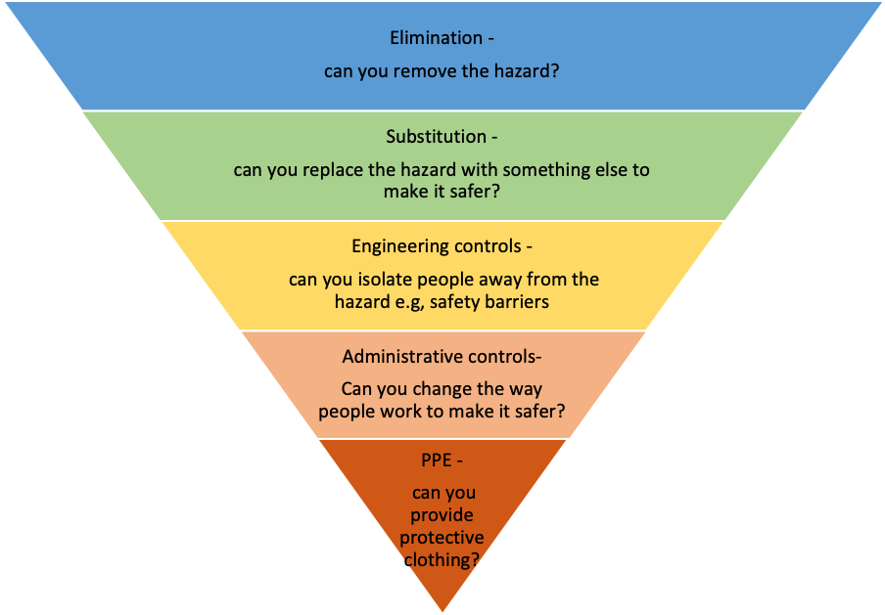

Most effective

Least effective

|  |  |
| --- | --- |
| **Hazards** | **Examples of how can you reduce the risk of the hazard (mitigations)** |
| **Where are you going?**  Are you travelling somewhere? What hazards are linked to you all going somewhere? | * Make sure that a trip form has been filled in with everybody’s emergency contact details and sent over to opportunities so that this can be forwarded onto the security team. * Ensure that we make sure we are aware of people’s medical conditions or allergies and what medication they need in case of an emergency. * Make sure that all relevant insurance has been taken out. * Ensure that everybody going on the trip has an up to date passport and EHIC card. * Ensure that there is a backup plan in case of failed transport mode. * Ensure that people take relevant clothing and footwear for the trip. * Ensure that the trip is ATOL protected. * Ensure that the accommodation is booked with a valid provider and it is a good standard. * Have you made sure you’ve done vehicle checks? Particularly if you’re using your own, personal car? |
| **Will there be lots of stuff on the floor at your event?**  Tripping, Slipping, falling from height, being struck by an object or walking into something | * Ensure that all spills are cleared up immediately, ensuring that somebody stays by the spill until it can be cleared and wet floor signage can be put by the wet floor. * Keeping bags out of public walkways. * Make sure that all wires are taped down or are out of the way of public walkways. * Try to avoid working at height. * Make the object that could easily be walked into easily visible with signs to warn people to be careful. * In the case of unavoidable accidents, ensure you are either with somebody who is first aid trained or make sure you are aware of where the nearest first aider is. * For accidents needing more than a first aider, ensure that emergency services are called. * Ensure all accidents and near misses are recorded so that the hazard can be mitigated further in the future. |
| **Are you using chemicals? (Including chalk)**  How will you check it’s not dangerous? Will it affect skin? How will you avoid ingestion or inhalation in lungs? Are you using anything that’s flammable or compressed? | * If using chalk, make sure the opportunities team are informed immediately. * Ensure that the chalk policy is adhered to and sent through to the open spaces team. Where possible, do not use chalk. * Always read the back of any products you are using to ensure that it is safe. If it is not safe, these products will not be used. * To ensure that skin is not affected, gloves, masks and other relevant protective wear should be worn. * Ensure that a safety briefing is given at the beginning of the event so that people use the equipment correctly and safely, making sure you let people know that the products are not safe to eat. |
| **Are you working with animals or anything that may be infectious?** How will you avoid contamination? | * Ensure that everybody involves washes their hands after touching animals. * If applicable, provide footwear covers to avoid contamination in clean areas. * Ensure you provide signage informing people not to touch their mouth and eyes directly after petting animals. * Provide antibacterial gel and or wipes. * If possible, have an animal handler on site to manage all of the animals. * If any of the animals bite, make sure you go to the doctors to get the bite checked over. |
| **Are you making it loud, dark or hot/cold?**  How will you manage excessive noise, poor lighting or ensuring people stay warm or cool? | * Ensure that any music is kept to acceptable levels. * Ensure that a pre event brief takes place to make sure everybody is in agreement about the level of music. * Ensure sufficient lighting is available, even if it is an event in the dark, such as torches. Always visit the venue beforehand to make sure sufficient lighting is available for your activity. * Inform event attendees if strobe lighting is going to be used by displaying appropriate signage and make sure they are also warned beforehand. * If it is likely that people will get too hot, ensure that they are wearing appropriate clothing, have easy access to water and bring things like sun cream and sun hats if it is a hot day. * If it is an event where people are likely to get cold, ensure that they have appropriate warm clothing and make sure that people are not out in the cold for too long and have easy access to food and water should they need it. * If your event is taking place inside, ensure windows can be opened if it’s a hot day or heaters can be provided if it’s extra cold. * Think about the activity – will it change the temperature of people e.g, dancing? |
| **Have you planned this and delegated jobs to make sure it all goes to plan?**  Have you got enough people helping you to do this event? Are they clear on what they need to do? Is there clarity on who’s in charge? | * Ensure an event management plan has been put in place so everybody knows what they are in charge of doing at the event. * Hold an event briefing session prior to the event to ensure you’ve checked in with people at the venue to make sure they are also clear of what is happening. * Create a staffing rota to ensure all jobs get done in the timeframe they are needed. * Assign someone to be in charge (event manager) who can be the first port of call if there’s questions or queries. * Ensure your event management plan has a list of key contacts and their contact details are provided. |
| **Is it possible for anyone to get angry at your event?**  How will you manage this? Who will help you? What will you do in an emergency? Have you introduced yourself to a venue security guard? | * If you have security at your event, ask them to help you control the situation, escorting them out of the event if necessary. * Make it clear that you do not tolerate aggressive behaviour before the event takes place. * Ensure this is escalated as soon as possible to a duty manager. * If the situation becomes violent or the person is causing a danger to others, call 999/UEA security * Have someone at your event that has had Mental Health First Aid training |
| **Could any bullying happen at your event?**  How can you stop people picking on others, excluding others, deliberately ignoring, making jokes about a single person? | * Ensure that you make it clear that bullying in any form will not be tolerated at the event. * Nominate somebody in your society committee to go round and check if everybody is ok and keep an eye on things. * Consider if certain games are being played. Are they inclusive? * Do not promote initiations of any kind, but especially any that involve individuals being pressurised to drink alcohol. |
| **Are there drink or drugs at your event?**  How will you prevent people getting too drunk? Taking drugs? Ensure they get home safe? Or prevent them putting themselves in a vulnerable position? | * Ensure at least one person from the society will be nominated to not drink so they can keep an eye on everybody and be the point of call for any emergencies. The ratio should be 1 person not drinking to 30 people drinking. * Ensure that you make it clear before the event that people who are too drunk will be asked to leave the event. * Make it clear before the event that there is a zero tolerance policy for drugs and anybody found to be taking drugs will be asked to leave and may be refused entry at future events and UEA Security/the police may be informed. * If somebody appears to be too drunk, escort them home. * Provide people with recommended ways to get home and trusted taxi numbers. Inform people about the safer taxi scheme. * Ensure there’s free drinking water available and non-alcoholic drink options. * Avoid drinking games. * Do not promote initiations of any kind, but especially any that involve individuals being pressurised to drink alcohol. |
| **Are you using any electrical equipment?**  When did you get your kit last checked has it failed recently? Are you going to overload sockets or have lots of extensions? Have you got authorisation to use power in external venues? | * Only members of the society will be using sockets so it can be controlled what is going into the sockets. * Sockets will not be overloaded. * All equipment will be checked before the event to ensure that it is safe to use. * We will get authorisation from our venue to check if we are allowed to use their power sockets. * Ensure electrical equipment over two years old is PAT tested. * Ensure electrical cables are secured and not providing a trip hazard. * Know the location of a first aid kit. * Keep liquids away from electrical equipment. |
| **You should always think about fire hazards!**  Could there be a fire at your event? Is there any naked flames? Could any of the stuff you are using catch fire? Are you cooking? Have heaters? How will you evacuate and keep fire exits clear? | * Ensure that all attendees at the event are aware of what to do in the event of a fire. * Nominate one person to be the fire warden for the event and escort people out of the building safely in the event of a fire and to alert security. * Keep flames away from other items that may set alight. * Keep all fire exits clear. * Ensure that all electrical equipment and cookers are switched off when not being used. * Do not place items such as clothes and jackets on top of electrical items such as toasters, portable heaters, lamps. * Ensure you know where the fire extinguishers are located. * Call 999. |
| **How will you get people in and out?**  Do you know how many people are coming and whose coming? Are exits and entrances clearly marked? If everyone had to leave at once would people trip? | * Have members of the committee on the door of the event to help get people in and out of the event safely. * Have a one way in, one way out policy to ensure safe entry and exit of the building. * Ensure that no entrances and exits are blocked, reducing the risk of trips. * All fire exits will be kept clear. * Don’t exceed the capacity of the venue. * Security will be at the event to help control people getting in and out of the building safely. |
| **Letting people know what’s going on? What to do in an emergency?**  Do you need signs or safety briefings before starting? | * Ensure that all members of the committee are briefed beforehand of what is happening and who is in charge of what. Make sure that everybody knows what they should do in an emergency. * If on a trip, emergency contact details should be taken in case you need to contact next of kin. * A first aider will be on site in case of an emergency. |
| **Will you ever be off the ground and doing things at height?** If so how will you do this if you don’t have ladders? Can you ask the venue to put decorations up beforehand? | * Try to avoid doing this. Ask somebody at the venue to do this for you. * If using ladders, always ensure that somebody is supporting the ladder at the bottom. * If doing an activity at height such as at ‘go ape’ make sure you always listen to the instructors and ensure that all attendees are wearing the correct safety equipment. |
| **Keeping it clean and tidy. Does your event have lots of stuff or things thrown on the floor?**  How are you going to keep the place clean and tidy? If someone spills something or the toilet overflows what’s your plan? | * Ensure that checks are made at the end of the event to make sure that everything has been left as you found it. * Any spills should be cleared up immediately, asking the venue to help if needed. * Any problems above and beyond what you can resolve should be reported to the venue so that somebody else can help. * Ensure there is a designated place for coats and jackets to be stored to avoid trip hazards. * Provide a safe space to keep bags and belongings. * Have a team to help clean up after the event. |
| **Will you move and carry things around?**  Do you have people who can do this? Do they know how to lift? Could you get a trolley? | * Ensure that only members of the society will move furniture around. * Make sure that people lifting things will only lift weights that they are comfortable with. * Remind people to bend their knees when lifting things rather than bending their backs. * Try and source a trolley for heavy items if necessary. * Ensure that people receive manual handling training. |
| **Could anyone at your event disclose sensitive information or** **show signs of** **mental ill health.** Is there someone in your student group that would know how to help them? | * Make sure you warn of any triggering content before the event and let people know that it’s fine to leave should they wish to. * Ensure members of the team advise attendees to seek help from the advice team should they need it. * Have a member at your event that has undertaken good night out training. * Give a brief on where to signpost people to should they need it. * Is anybody mental health first aid trained that could attend the event to help? |
| **Will you be near transport links or the road?** How will you keep people safe if around a road? And what checks will you make if you are driving or being driven? | * Make sure you plan your journey carefully. * If there is a large group, dedicate somebody to ensure people are crossing the roads safely. * If somebody is driving, make sure that their insurance covers them to take other people in their car. Also ask them to show their driving licence and prove that the car is taxed and insured if using a personal vehicle. * If hiring a car, the car hire company will carry out their own checks to ensure that the person driving is allowed to do so. * Ensure that the driver is not distracted by passengers. * Help with directions will be provided by passengers if needed. |
| **Are you inviting the public to your event?**  Do you know who they are and how many people are coming? Somebody has come I don’t want to be here – what do I do? There’s children coming? | * Ensure that you get people to buy a ticket from the website, even if the event is free. * Ensure that you do not exceed the capacity of the venue and keep track of how many people are coming in. * If somebody attends who is causing trouble or who is not supposed to be at the event, ask them to leave and involve security/venue staff if needed. * If there’s children coming, make sure that they are accompanied by somebody over the age of 18. Also make sure that the content is suitable for children and if not, a minimum age should be published before the event. |
| **Who’s taking the money?**  Are you taking money at your event? What’s your plan to cash it in? | * Ensure that all tickets are sold via the website and do not sell tickets before the event in any other way. * Any leftover tickets will be sold at the door in cash. Nominate certain members of the society to be in charge of the money. * You need to cash the money straight into the bar after the event so that the money can go directly to your subs account. Do not take any cash away with you. * Make sure that you have cash tins to keep your money in so that it is safe and out of sight of the public. |
| **Guest speakers?**  Who is looking after the speaker? Will anyone not like your speaker? Will anyone argue about your speaker? Will your speaker offend anyone? | * Ensure that you give the SU at least 4 weeks’ notice for external speakers so that relevant checks can be made. * Ensure that you forward over the guest speaker policy to all external speakers. * Make sure that external speakers are all given a clear brief of what to speak about and check their content before the event to make sure that they do not go off topic. * Make sure that you stop the external speaker should they go off topic. * Notify security that the event is happening and call them in the event of an emergency. * Plan a safe route that the external speaker can leave the building should any problems arise from the audience. |
| **I’m going to take lots of pictures?**  Have you asked people if they are fine with that? Have you put signs up saying this? | * Make people aware on the ticket information that photography and videography will be taking place and to let you know if there are any problems. * Provide wristbands for those people who have specifically been asked to not be in any photos or videos so that they can be easily identified. * Make sure that you put up signs around the building to notify of any photography or videography that is happening throughout the event. |
| **Are you going to be providing food at the event?**  How are you going to manage allergies? Do you have a food hygiene certificate? | * As the event is taking place in the SU you will be hiring in external caterers and letting them know of any allergies that they need to cater for prior to the event. You will ask all attendees to provide information on their allergies. * Everybody who is selling food or preparing food has to have a Level 2 food hygiene certificate. You are aware that if they don’t have one you are not allowed to provide food. * You will ensure that food will be kept in correct conditions such as warm or cool (explain how you will do this). * If the event is taking place in an external venue, you will provide them with allergen details provided by the attendees prior to the event. * If the event is taking place in a UEA building, you are aware that you can only use UEA catering and you will provide them with all allergen information gathered from attendees prior to the event. * You will make sure that allergen information is easily available for all attendees to have access to. * You will buy pre-packaged food from a supermarket and make the allergens available to all attendees. All of the food will be cupboard food that can be kept out at all times such as crisps, sweets and biscuits. |
| **Covid-19**  Could somebody turn up to the event showing Covid-19 symptoms?  Could somebody contact Covid-19 at the event?  Could somebody report that they have tested positive for Covid-19 after attending your event? | * You will ensure that individuals from different households will social distance, maintaining a distance of at least 2 metres. * You will use a facility or location suitable to permit the planned number of attendees to adequately socially distance from others. * Your activity or event is designed to limit or remove aspects of close personal contact with others. * Your event will only involve activities permitted by the guidance from the UK Government and where relevant National Governing Bodies. * Your event will be approved by either UEA Sport or UEASU before it goes ahead or you start advertising your event. * You will use a facility or location that has readily available hot running water for people to regularly wash their hands. * You will provide liquid soap at your event. * You will provide hand sanitiser, for use in addition to soap and water for handwashing. * You will bring or provide suitable cleaning products to wipe down any equipment used that isn’t provided by your venue. * You will remind all attendees not to attend if they are displaying symptoms of the Coronavirus. * You will ticket the event or activity via the SU website which will act as a record of all attendees and take a register on site at your event and keep this for 21 days following the event as a track and trace system. * You will encourage everybody to log their location on the NHS test and trace app in addition to your track and trace system. * You will give the details of any symptomatic individuals to the Students’ Union immediately and follow UEA and UEASU guidance on what to do in the event of an outbreak within your event or student group. * You will minimise the shared use of high-contact items or equipment wherever possible. * You will provide hard surface wipes so that items can be wiped down before and after an event; and between each individual use. * You will follow the Students’ Union policies, to ensure that appropriate services (for example, campus control) are aware of your activity and alternative emergency support arranged where necessary. * You will ensure that you are located appropriately to toilet facilities that are open and available for your attendees and look into the nearest toilet facilities before your event takes place. * You will be located appropriately to ensure that toilet facilities are subject to a regular cleaning schedule * You will minimise the need for attendees to travel using public or group travel services (planes, coaches, buses, taxis) * You will support attendees to source appropriate Personal Protective Equipment (such as face coverings) where public transport is required. * You will playing music and films at an appropriate volume that will not need or encourage people to shout or talk loudly, which would otherwise encourage the risk of virus transfer. * You will space out the seating in an appropriate manner, ensuring anybody who is not in the same household is socially distanced from each other. * You will do the activity in a larger outdoor space, rather than in a small, indoor space. * You will ensure that attendees at your event will wear face coverings where required, unless they are except from wearing one. * You will have signs at your event, notifying attendees where they have to wear a mask. * You will email all attendees before your event, explaining all of the rules and regulations at your event to enable you to keep the event covid secure. |